# General Data & Information

|  |  |  |  |
| --- | --- | --- | --- |
| Panel No. |  | Rated current | 1A |
| Relay Type | 87L-1/21-1/67N-1 | Rated voltage | 110-220V |
| Manufacturer | ABB | DC. Auxiliary. Voltage | 90-250VDC |
| Serial No. | T | Frequency Fn | 50/60 Hz |
| Order - No. | 1MRK004810-DC | Firmware Version |  |
| Product def. |  | Draw. & Sh No. : |  |
| CT Ratio : ______ | 1600/1A | VT Ratio |  |
| Circuit Breaker No. |  | Scheme type |  |

[..\WorkInstructions\69.pdf](../WorkInstructions/69.pdf)

**For Mechanical Check/Visual Inspection and Electrical Tests Use C.L. of W.I. 69**

2.0 Mechanical Checks and Visual Inspection

|  |  |  |  |
| --- | --- | --- | --- |
| item | Description | Remarks | |
|  | Inspect for any physical damage or defects. | ❑ Yes | ❑ N/A |
|  | Verify connections and ferrules as per approved drawings | ❑ Yes | ❑ N/A |
|  | Check tightness of all the connections. | ❑ Yes | ❑ N/A |
|  | Check Apparatus List | ❑ Yes | ❑ N/A |
|  | Check relay version and switching elements on printed circuit board | ❑ Yes | ❑ N/A |

# Electrical Tests

# Function Test

|  |  |  |  |
| --- | --- | --- | --- |
| Item | Description | Remarks | |
|  | Human Machine Interface (HMI) Checked. | ❑Yes | ❑N/A |
|  | Case Earthing checked. | ❑Yes | ❑N/A |
|  | LED’s Function Checked. | ❑Yes | ❑N/A |
|  | Trip Contacts Checked. | ❑Yes | ❑N/A |
|  | Reset Function Checked | ❑Yes | ❑N/A |
|  | Group active Functions Checked | ❑Yes | ❑N/A |
|  | Binary inputs checked. | ❑Yes | ❑N/A |
|  | Output Relays Checked | ❑Yes | ❑N/A |
|  | Event Display on HMI Screen Checked | ❑Yes | ❑N/A |
|  | Test switch / plug checked for correct function. | ❑Yes | ❑N/A |
|  | Watchdog contacts checked | ❑Yes | ❑N/A |
|  | Current shorting facility. | ❑Yes | ❑N/A |

# Operating DC supply current

|  |  |  |  |
| --- | --- | --- | --- |
| Applied DC voltage  (V) | DC current w/o fault (mA) | DC current with fault (mA) | Max. calculated watt (W) |
|  |  |  |  |

Limit: DC burden 50 watts. (Refer to the reference technical manual page 391).

# Watch Dog Check

SUPPLY OFF

TERMINALS (CLOSED) - (X11:2,X11:3) :

TERMINALS (OPEN) - :(X11:1,X11:2) :

SUPPLY ON

TERMINALS (CLOSED) - :(X11:1,X11:2) :

TERMINALS (OPEN)- (X11:2,X11:3) :

# Time and Date Check

To check time & date go to main menu on the display for RED670 then open system time and adjust time & date.

To test keeping time and date setting this, remove the auxiliary supply from the relay for approximately 30 seconds, then restoring the auxiliary supply, the time and date setting should not be lost.

Result: ______________

# Setting Adopted

Refer enclosed setting page

|  |  |  |  |  |  |
| --- | --- | --- | --- | --- | --- |
| **Distance/other functions** | | | | | |
|  | **Description** | **Parameters** | **Settings** | **Remarks** |
|  | **Line reference** | Line length |  |  |
|  |  | R1A |  |  |
|  |  | X1A |  |  |
|  |  | R1B |  |  |
|  |  | X1B |  |  |
|  |  | R1L |  |  |
|  |  | X1L |  |  |
|  |  | R0L |  |  |  | |  |
|  |  | X0L |  |  |
|  |  | R0M |  |  |
|  |  | X0M |  |  |
|  | **Zone 1** | Operation |  |  |
|  |  | Operation Dir |  | ZONE REACH |
|  |  | X1 |  | P-E |
|  |  | R1 |  | Reach at 0° ,180° = RFPE.CT/VT |
|  |  | X0 |  | Reach at 90°, 270°=1/3.(2.X1 + X0).CT/VT |
|  |  | R0 |  | P-P |
|  |  | RFPP |  | Reach at 0° ,180° = RFPP/2.CT/VT |
|  |  | RFPE |  | Reach at 90°,270°= X1.CT/VT |
|  |  | Operation PP |  |  |
|  |  | Timer tpp |  |  |
|  |  | .tpp |  |  |
|  |  | Operation PE |  |  |
|  |  | Timer Tpe |  |  |
|  |  | .Tpe |  |  |
|  |  |  |  |  |
|  | **Zone 2** | Operation |  |  |
|  |  | Operation Dir |  |  |
|  |  | X1 |  |  |
|  |  | R1 |  |  |
|  |  | X0 |  |  |
|  |  | R0 |  |  |
|  |  | RFPP |  |  |
|  |  | RFPE |  |  |
|  |  | Operation PP |  |  |
|  |  | Timer tpp |  |  |
|  |  | .tpp |  |  |
|  |  | Operation PE |  |  |
|  |  | Timer Tpe |  |  |
|  |  | .Tpe |  |  |

|  |  |  |  |  |
| --- | --- | --- | --- | --- |
|  | **Description** | **Parameters** | **Settings** | **Remarks** |
|  | **ZONE 3** | Operation |  |  |
|  |  | Operation Dir |  |  |
|  |  | X1 |  |  |
|  |  | R1 |  |  |
|  |  | X0 |  |  |
|  |  | R0 |  |  |
|  |  | RFPP |  |  |
|  |  | RFPE |  |  |
|  |  | Operation PP |  |  |
|  |  | Timer tpp |  |  |
|  |  | .tpp |  |  |
|  |  | Operation PE |  |  |
|  |  | Timer tPE |  |  |
|  |  | .tPE |  |  |
|  |  |  |  |  |
|  | **ZONE 4** | Operation |  |  |
|  |  | Operation Dir |  |  |
|  |  | X1 |  |  |
|  |  | R1 |  |  |
|  |  | X0 |  |  |
|  |  | R0 |  |  |
|  |  | RFPP |  |  |
|  |  | RFPE |  |  |
|  |  | Operation PP |  |  |
|  |  | Timer tpp |  |  |
|  |  | .tpp |  |  |
|  |  | Operation PE |  |  |
|  |  | Timer tPE |  |  |
|  |  | .tPE |  |  |
|  |  |  |  |  |
|  |  |  |  |  |
|  |  |  |  |  |
|  |  |  |  |  |
|  |  |  |  |  |
|  |  |  |  |  |
|  |  |  |  |  |
|  |  |  |  |  |

|  |  |  |  |  |
| --- | --- | --- | --- | --- |
|  | **Description** | **Parameters** | **Settings** | **Remarks** |
|  | **Diff function** |  |  |  |
|  |  | Operation |  |  |
|  |  | IdMin |  |  |
|  |  | Endsection 1 |  |  |
|  |  | Endsection 2 |  |  |
|  |  | Slope section 2 |  |  |
|  |  | Slope section 3 |  |  |
|  |  | IdMinHigh |  |  |
|  |  | IntervIdMinHig |  |  |
|  |  | IdUnre |  |  |
|  |  | NegSeqDiff |  |  |
|  |  | IMinNeqSeq |  |  |
|  |  | ChargCurEnable |  |  |
|  |  | Adddelay |  |  |
|  |  | Open CT |  |  |
|  |  | .tOCTAlarm delay |  |  |
|  |  | .tOCT reset delay |  |  |
|  |  |  |  |  |
|  |  |  |  |  |
|  |  |  |  |  |
|  | **Powerswing Detection** |  |  |  |
|  |  | Operation |  | FW = RLdOut – RldIn |
|  |  | X1InFw |  | X1Out = (X1In + FW).CT/VT |
|  |  | R1Lin |  | R1Out = (R1In+ FW).CT/VT |
|  |  | R1FinFw |  |  |
|  |  | X1InRv |  |  |
|  |  | R1FINRv |  |  |
|  |  | OperationLdCh |  |  |
|  |  | RLdOUTFw |  |  |
|  |  | ArgLd |  |  |
|  |  | RLdOUTRv |  |  |
|  |  | KLdRFw |  |  |
|  |  | KLdRRv |  |  |
|  |  | .Tef |  |  |
|  |  |  |  |  |
|  |  |  |  |  |
|  |  |  |  |  |

|  |  |  |  |  |
| --- | --- | --- | --- | --- |
|  | **Description** | **Parameters** | **Settings** | **Remarks** |
|  | **PHS-PHASE** |  |  |  |
|  | **SELECTION** |  |  | PHASE SELECTION REACH |
|  |  | RLdFw |  | P-N |
|  |  | RLdRv |  | Reach at 0° = RFFwPE..CT/VT |
|  |  | X1 |  | Reach at 180° = RFRvPE.CT/VT |
|  |  | X0 |  | Reach at 90° = 1/3. (2.X1 + X0).CT/VT |
|  |  | RFFwPP |  | Reach at 270° = .X1.CT/VT |
|  |  | RFRvPP |  | **P-P** |
|  |  | RFFwPE |  | Reach at 0° = RFFwPP/2.CT/VT |
|  |  | RFRvPE |  | Reach at 180° = - RFRvPP/2.CT/VT |
|  |  | ArgLd |  | Reach at 90° = X1.CT/VT |
|  |  |  |  | Reach at 270° = -X1.CT/VT |
|  |  |  |  | 3PHASE |
|  |  |  |  | Reach at 0° = 1.1 . RFPP/loop..CT/VT |
|  |  |  |  | Reach at 180° = -1.1 . RFPP/loop..CT/VT |
|  |  |  |  | Reach at 90° = 4/3 . X1.CT/VT |
|  |  |  |  | Reach at 270° = -4/3 . X1.CT/VT |
|  |  |  |  | Reach at 0° = RFFwPE..CT/VT |
|  |  |  |  |  |
|  |  |  |  |  |
|  |  |  |  |  |
|  |  |  |  |  |
|  |  |  |  |  |
|  |  |  |  |  |
|  |  |  |  |  |
|  |  |  |  |  |
|  |  |  |  |  |
|  |  |  |  |  |
|  |  |  |  |  |
|  |  |  |  |  |
|  |  |  |  |  |
|  |  |  |  |  |
|  |  |  |  |  |
|  |  |  |  |  |
|  |  |  |  |  |
|  |  |  |  |  |
|  |  |  |  |  |

# Secondary Injection Tests

# Distance Protection

# Zone Reach Measurements:

|  |  |  |
| --- | --- | --- |
| Item | Description | Checked |
| 1 | Print out from Freja attached. |  |

PH-E (PE): -Resistive reach: RFn (Ω/loop) = RFn (Ω/phase) = RFPE

-Reactive reach: XFn (Ω/loop) = XFn (Ω/phase)

= Xn (Ω/phase) + X1 (Ω/phase)= (2*X1 + X0) / 3

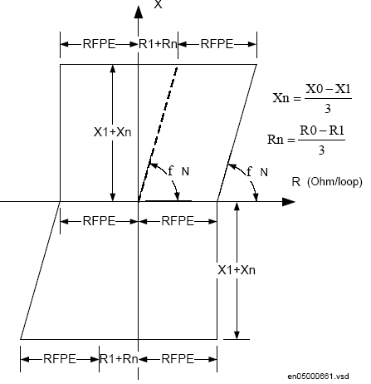 Chars. Angle = -15 to 115 at FW Direction

PH-PH (PP): -Resistive reach: RFn (Ω/phase) = ½ RFn (Ω/loop) = ½ RFPP.

- Reactive reach: XFn (Ω/phase) = ½ Xn (Ω/loop) = X1.

RFn: Zone n resistive reach resistance.

XFn: zone n positive sequence reactance.

X0 : line zero sequence reactance.

X1 : line positive sequence reactance.

3 PH: Same setting like PH-PH but, note PHS is rotated by 30o at 3PH, Due to that, zones at resistive reach is reduced

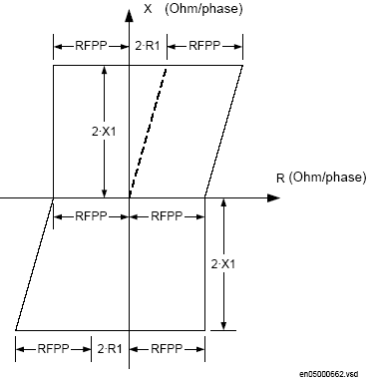

# Zone Timing Test:

|  |  |  |
| --- | --- | --- |
| Item | Description | Checked |
| 1 | Print out from Freja attached. |  |

Limit: 28-33 ms ± 10ms ± 0.5 %.

# Phase Selection Function (PHS)

# PHS Reach measurements

|  |  |  |
| --- | --- | --- |
| Item | Description | Checked |
| 1 | Print out from Freja attached. |  |

|  |  |  |
| --- | --- | --- |
| Setting given as (Ω/loop ) not (Ω/phase ) |  |  |
| PHS , with Phase-to-Phase | PHS , with Phase-to-Earth | PHS , with 3 Phase |

PH-E (PE): -Resistive reach: RFphs (Ω/loop) = RFphs (Ω/phase) = RFFwPE.

-Reactive reach: Xnphs (Ω/loop) = Xnphs (Ω/phase)

= (2*X1 + X0) / 3

PH-PH (PP): -Resistive reach: RFphs (Ω/phase) = ½ RFphs (Ω/loop) = ½ RFFwPP

- Reactive reach: X1phs (Ω/phase) = ½ X1phs (Ω/loop) = X1phs (Ω/phase).

3PH: -Resistive reach: RFphs (Ω/phase) = 1.15 RFphs (Ω/phase).

- Reactive reach: X1phs (Ω/phase) = 1.335 * X1phs (Ω/phase).

Take in consideration that, although PHS rotate by 30 0, it still keep directional angle (-15, 115) as its starting boundary

# PHS timing test:

|  |  |  |
| --- | --- | --- |
| Item | Description | Checked |
| 1 | Print out from Freja attached. |  |

Limit: 28-33 ms ± 10ms ± 0.5 %.

# Power Swing Detection (PSD)

# PSD Reach test Measurement

|  |  |  |
| --- | --- | --- |
| Item | Description | Checked |
| 1 | Print out from Freja attached. |  |

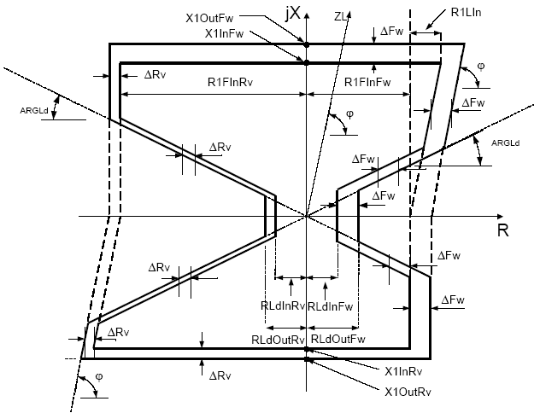

Where:

RLdFw = KLdRFw * RLdOutFw

RLdIn = KLdRRv * RLdOutRv

# Timing Test:

# CHECK THE OPERATING TIME (TP1)

|  |  |  |
| --- | --- | --- |
| Type of fault | Tp1 setting ms | Tp1 actual ms |
| 3 phase | 45 |  |

*TP1:* it is the smallest time can be passing from outer boundary to inner boundary of Power Swing Chars. to detect PSD Start -Freja general mode, sequence, 3 stages.

-1ST STAGE: Normal Load, 3phase Vr&Ir, outside the outer zone area

-2nd STAGE: 3phase V&I to get the impedance inside the PSD zone (I=Ir & V/I<Zouter and

T =Tp1).

-3RD STAGE: 3phase V&I to get the impedance outside PSD zone and pass the inner boundary

(I=Ir & V/I<Zinner and T =1 SEC).

Change 2nd stage timing till get PSD operating time exactly.

(Use zone tripping contact)

# CHECK THE BLOCKING TIME (t R2):

|  |  |  |
| --- | --- | --- |
| Zones | Time Measured without PSB | Time Measured with PSB |
| Zone 1 |  |  |
| Zone 2 |  |  |
| Zone 3 |  |  |
| Zone 4 |  |  |

Limit: ± 10 ms (see the tech. ref. manual page 90).

*tR2:* if the PSD is detect a 3Phase zone fault for time is longer than tR2, then it Block PSD function.

- FREJA GENERAL MODE

-1ST STAGE: 3PHASE healty V&I (I=Ir, V/I >outer zone setting impedance).

-2ND STAGE: 3PHASE V&I (I=Ir, V/I <inner zone setting impedance).

-3RD STAGE inside 3Ph fault for time >= tR2.

-change the time of 3rd stage till get trip, which mean blocking of PSD

# Check of the blocking function

|  |  |  |
| --- | --- | --- |
| Item | Description | Checked |
| 1 | Blocking of zone 1, 2 & 3 |  |

Test procedure: same as before only change the time for 3rd stage to be less than tr2 sec. and test that for each zone.

**iv** **. Check of the relay tripping during power swing if a single phase faults Occurred, tR1**

*tR1:* if the PSD is detect a single phase fault, so after time equal to tR1, then it Block PSD function

- FREJA GENERAL MODE

-1ST STAGE: 3PHASE V&I (I=Ir, V/I > outer zone setting impedance).

-2ND STAGE: 3PHASE V&I (I=Ir, V/I < inner zone setting impedance).

-3RD STAGE outside PSD for time < tR2.

-4RD STAGE inside 1Ph fault for time >= tR1

-change the time of 4th stage till get trip, which mean blocking of PSD

|  |  |
| --- | --- |
| SETTING VALUE | MEASURED VALUE |
| 300msec |  |

# V .CHECK THE FAST PSD TIME (tP2)

*tP2:* it is second operating timer for PSD (Fast PSD), if PSD occur for second time at interval equal to *Tw*.

FREJA GENERAL MODE

-1st STAGE: 3PHASE V&I (I=Ir, V/I >outer zone setting impedance).

-2nd STAGE: 3PHASE V&I (outer zone > I=Ir, V/I > inner zone setting impedance) for time >= tP1.

-3rd stage: 3PHASE V&I (I=Ir, V/I <inner zone setting impedance) for time = 100 ms.

-4th stage leave PSD and back to normal load for time < Tw.

-5th stage pass outer PSD for time >= tP2

-6th stage pass inner PSD

Note, you must minimize the TH, which is the holding time for PSD starting signal

-change the time of 4th stage and 5th stage to get Tw, tP2 timers

|  |  |  |
| --- | --- | --- |
| Timer | SETTING VALUE | MEASURED VALUE |
| Tw | 250 ms |  |
| tP2 | 15 ms |  |

# 3.6.8 Current Sensitivity Test

|  |  |  |  |  |  |  |  |  |  |
| --- | --- | --- | --- | --- | --- | --- | --- | --- | --- |
| **Phase** | **Setting (A)** | | **Expected (A)** | | **Pickup (A)** | | | | |
| **PHS** | **Is** | **PHS (A)** | **Zn n=1,2,3,4,5** | **PHS** | **Z1** | **Z2** | **Z3** | **Z4** |
| **FW** | **FW** | **FW** | **RV** |
| R | 5% | 20% | 0.050 | 0.2 |  |  |  |  |  |
| Y | 5% | 20% | 0.050 | 0.2 |  |  |  |  |  |
| B | 5% | 20% | 0.050 | 0.2 |  |  |  |  |  |

* Is Zone min Operating Current
* Reverse Zone Start at 75% of Forward value

# Directionaltest

RV

295O

ND

345O

165O

115O

90O

180O

FW

ND

Line characteristic angle:

Relay directional angles: ArgDir (15) and ArgNegRes (115)

a) Forward direction; the operating chs Area from: ________ to: **__________**

b) Reverse direction; the operating chs Area from: _________to: __________

Test procedure: -

Apply Single Phase V & I Under PHS Setting.

- change the voltage angle from 0 degree up to 360 degree until the indication of FW,and REVERSE appears as per setting applied. (Switch off zone tripping)

# SCHEME COMMUNICATION TEST

tcoord set : 0 m sec

Zone-2 Set Time : ms

**a) PERMISSIVE UNDER REACH SCHEME :**

Send logic : CS = ZM1 :

Trip logic : Trip = ZM2 + CR :

Trip time without CR :

Trip time with CR :

Time send :

**b) PERMISSIVE OVER REACH SCHEME :**

Send logic : CS = ZM1&ZM2 :

Trip logic : Trip = ZM2 + CR :

Trip time without CR :

Trip time with CR :

Time send :

**c) BLOCKING SCHEME :**

Send logic : CS = ZM4 :

Trip logic : Trip = ZM2 + NO CR :

Trip time without CR :

Trip time with CR :

Time send :

**d) DIRECT INTERTRIP SCHEME :**

Send logic : CS = ZM1 :

Trip logic : Trip = CR :

Trip time :

Time send :

**e) DIST WEI ECHO (Select scheme : POR)**

t WEI set : 1.0 sec , Measured :  sec

Prolongation time fixed : ≤ 200 msec , Measured :  msec

Apply Reverse fault and check No ECHO send :

**f) DIST WEI TRIP**

t WEI set : 0.1 sec , Measured : __________ sec

**U/V Check**

|  |  |  |  |
| --- | --- | --- | --- |
| PHASE | U Ph setting | U Ph Calculated (V) | U Ph Measured (V) |
| R  Y | 70%  70 |  |  |
| Y | 70% |  |  |
| B | 70% |  |  |

1. Check CB open and No WEI Trip :

**g) CURRENT REVERSAL LOGIC:**

t pickup set : 0.040 sec

t delay set : 0.100 sec (Apply Reverse/Forward Fault )

Measured trip time:  **______** msec Measured send time : ________msec

# Polarization Voltage:

It is the voltage needed to determine the directionality, when no healthy voltage is available.

Relay use cross polarizing (from other healthy phase), or from memory circuit.

SOTF must be disabled before do following tests.

1. **Minimum Voltage to be registered: smallest positive sequences voltage relay can store at its memory.**

- FREJA GENERAL MODE

-1ST STAGE: 3PHASE healthy Vr&Ir. (500msec)

-2ND STAGE: 3PHASE VMem &Ir (45msec)

-3RD STAGE 3PHASE Dead (V, I = zero) for time = 50 ms

-4RD STAGE Single Phase Fault (V = zero, I = Ir ) , and other 2 Phase is Dead (V, I = zero )

Change VMem till get smallest value cause trip.

Memorization Voltage: ______________ expected Value: 5% UBase (as TechRef. page 241)

1. **Minimum Time for register: smallest time where relay can use its registered voltage.**

- FREJA GENERAL MODE

-1ST STAGE: 3PHASE healthy Vr&Ir .

-2ND STAGE 3PHASE Dead (V, I = zero) for time =< Tregisterd

-3RD STAGE Single Phase Fault (V = zero, I = Ir), and other 2 Phase is Dead (V, I = zero)

Change Tregisterd till get smallest value cause trip.

Tregisterd:______________ expected Value: 100 ms (as TechRef. page 241)

1. Minimum Voltage used to reset memory after dead time: the memory voltage can be used for 100 ms after that if current is decrease below the Iminop setting then there is no directional indication until positive sequence voltage exceeds 10 % UBase.

- FREJA GENERAL MODE

-1ST STAGE: 3PHASE Vreset &I = Ir

-2ND STAGE 3PHASE Dead (V, I = zero) for time =< 100 ms

-3RD STAGE Single Phase Fault (V = zero, I = Ir), and other 2 Phase is Dead (V, I = zero)

Change Vreset till get smallest value cause trip.

Reset Voltage: _____________ expected Value: 10% UBase (as TechRef. page 241)

# Automatic Switch on to Fault (SOTF)

a) Operating Time

|  |  |
| --- | --- |
| **SOTF ACTIVATION** | **ACCELERATION ZONE 3 TRIP TIME (msec)** |
| No Activation (without close command) |  |
| External Activation (with close command) |  |
| Internal Activation |  |
| *tSOTF* (Drop delay of SOTF – set value 1.0 sec) | Measured: |

# Fuse failure supervision function (FUSE)

**MODE : UZsIs**

|  |  |  |  |
| --- | --- | --- | --- |
| Setting | | Measured Values | |
| 3U0>(V) | 3I0<(A) | 3U0>(V) | 3I0<(A) |
| 30% ( 19.05 V) | 10% ( 0.1A) |  |  |

3U0= Ua + Ub + Uc 3I0= Ia + Ib + Ic

Limit: ± 2.5 % of Ur for 3U0> and ± 2.5 % of 3I0r

**MODE : UNsINs**

|  |  |  |  |
| --- | --- | --- | --- |
| Setting | | Measured Values | |
| 3U2>(V) | 3I2<(A) | 3U2>(V) | 3I2<(A) |
| 30% ( 19.05 V) | 10% ( 0.1A ) |  |  |

# Fuse failure operating time : ____________ m sec.

Fuse failure resetting time : ___________ msec.

-1ST stage: 3phase v&i healthy case.

-2ND stage: put fuse fail condition (take contact fuse fail)

# Check the blocking of the relay when the general block functions

(VT MCB TRIP) is activated **[ _______ ].**

# Check the latching facility of fuse fail function [ ___________ ].

# V.T supervision latching time = ___________ sec.

Test procedure:

Disable opDUDI Mode.

Enable UZsIZs Mode.

Enable Seal In

General mode:

- 1ST stage: 3phases V&I healthy case. (Take time 1 sec)

-2ND stage: put 3 phase (v) to achieve the DLD and fuse fail for time >= latching time (5 second)

# Check the relay Tripping if a fault occurred during the internal fuse fail [ ___________ ].

General mode:

- 1st stage: 3phases V&I healthy case. (Take time 1 sec)

- 2nd stage: fuse fail condition (take time < 5 sec)

- 3rd stage: fault condition

# Check Reset fuse fail Voltage (USealIN < [ ___________ ]).

General mode:

- 1st stage: 3phases V&I HEALTHY case. (Take time 1 sec)

- 2nd stage: fuse fail condition (take time >= 5 sec) , till latch condition.

- 3rd stage: 3Phase , V = USealIn , I = Ir

Change V on 3rd stage till get the exact value of USealIn which reset the latched Fuse Failure.

USealIn>: _________________

USealIn>setting = 70% UBase

# Check DUDI Function

Enable opDUDI Mode.

Disable UZsIZs Mode.

Setting:

DU> = 60%UBase

DI< = 15%IBase

UPH> = 70% UBase

|  |  |  |  |  |  |
| --- | --- | --- | --- | --- | --- |
| Setting | | | Measured Values | | |
| DU>% | DI<% | UPH>% | D>% | DI<% | UPH>% |
| **60** | **15** | **70** |  |  |  |

1. To detect Fuse Failure on any phase, that phase must have a sufficient negative change at voltage (DU>), at same time no change at its current more than DI< as compared to other phases..

And the voltage to that phase must be lower than UPH >. Also healthy voltage of first page must be greater than UPH>

* Check DU>

- 1st stage: 3phases V>=UPH &I = Ir healthy case. (Take time 1 sec)

- 2nd STAGE: fuse fail condition ( V= VFFS , I = Ir ) and the other 2 phase is Vr ,

Ir (take time < 5 sec)

- Note Decrease VFFS until get Fuse Failure start and latch signal instantaneously, the difference at voltage between first and second stage is DU<.

* Check DI<

General mode:

- 1st stage: 3phases V=Vr &I = Ir healthy case. (Take time 1 sec)

- 2nd stage: fuse fail condition ( V< = UPH , I = Ir ) and the other 2 phase is Vr , Ir

(TAKE TIME < 5 SEC)

- Note Increase current at the FFS Phase till removes Fuse Failure condition.

* Check UPH>

General mode:

- 1st Stage or 2nd Stage: Now inject fuse fail condition and increase the voltage up to reset the FF condition.

# Service values for measurements

PH voltage applied: 63.5 V

PH current applied: 1.0 A.

Phase shift : 0,240,120 degree.

Frequency : 60 HZ.

CT ratio : 2000 /1A

VT ratio : 380/0.110 KV.

**Measurement values in local HMI:**

|  |  |  |  |  |  |  |  |  |  |
| --- | --- | --- | --- | --- | --- | --- | --- | --- | --- |
| **Channel** | **Injected  Values** | **Sec. Values** | **Primary Values** | | **Channel** | **Inject.  Values (A)** | **Sec. Values** | **Primary Values** | |
| **Excepted** | **Measured** | **Excepted** | **Measured** |
| **U1** |  |  |  |  | S | - | - |  |  |
| **U2** |  |  |  |  | P | - | - |  |  |
| **U3** |  |  |  |  | Q | - | - |  |  |
| **I1(TRM40)** |  |  |  |  | F | - | - |  |  |
| **I2(TRM40)** |  |  |  |  | PF | - | - |  |  |
| **I3(TRM40)** |  |  |  |  |  |  |  |  |  |

**\* Measurement values checked from the signal monitoring tool [ _________ ]**

**3.6.22 FAULT LOCATOR FUNCTION**

SETTINGS : Refer setting sheet attached

Fault locator : ON

Setting - % Percentage

Line length : km

|  |  |  |  |  |  |  |
| --- | --- | --- | --- | --- | --- | --- |
| **Fault type** | **Fault Impedance** | **Expected Display** | | **Actual Display** | | **Tripping zone** |
| **Km** | **%** | **Km** | **%** |
| **A-N** |  |  |  |  |  |  |
| **B-N** |  |  |  |  |  |  |
| **C-N** |  |  |  |  |  |  |
| **A-B** |  |  |  |  |  |  |
| **B-C** |  |  |  |  |  |  |
| **C-A** |  |  |  |  |  |  |
| **A-B-C** |  |  |  |  |  |  |

**Line Angle Calculation :**

$phe= \tan^{-1}\left(X0+2.X1 | R0+2.R1\right)$ =  **°**

$phph= \tan^{-1}\left\{X1 | R1\right\}=$**°**

**Line impedance Calculation :**

PH-E = (Xo+2.X1) /3 *CT/VT **= Ω**

PH-PH = X1*CT/VT  **= Ω**

**3.6.23 FOUR STEP PHASE OVERCURRENT PROTECTION:**

**STAGE 1**

|  |  |  |  |
| --- | --- | --- | --- |
| PHASE | SETTING (A) | PICK UP (A) | DROP OFF (A) |
| A | 1.0 |  |  |
| B |  |  |
| C |  |  |

**STAGE 2**

|  |  |  |  |
| --- | --- | --- | --- |
| PHASE | SETTING (A) | PICK UP (A) | DROP OFF (A) |
| A | 2.0 |  |  |
| B |  |  |
| C |  |  |

**STAGE 3**

|  |  |  |  |
| --- | --- | --- | --- |
| PHASE | SETTING (A) | PICK UP (A) | DROP OFF (A) |
| A | 3.0 |  |  |
| B |  |  |
| C |  |  |

**STAGE 4**

|  |  |  |  |
| --- | --- | --- | --- |
| PHASE | SETTING (A) | PICK UP (A) | DROP OFF (A) |
| A | 4.0 |  |  |
| B |  |  |
| C |  |  |

**OPERATING TIME STAGE (1&2)**

TMS=1.0 Limit : ±0.05% of set time or ±10ms

|  |  |  |  |  |  |
| --- | --- | --- | --- | --- | --- |
| Curve | Cal. time  @ 3* IS | Measured time (sec) | | | Limit |
| Phase | Stage 1 | Stage 2 |
| IEC standard inverse | 6.3 | C |  |  | 5.985 – 6.615 |
| IEC very inverse | 6.75 | A |  |  | 6.413 – 7.087 |
| IEC ext. inverse | 10 | B |  |  | 9.5 – 10.5 |
| IEC Long time inverse | 60 | A |  |  | 57.0 – 63.0 |
| IEC Definite time | 1.0 | B |  |  | 0.95 – 1.05 |

**OPERATING TIME STAGE (3&4)**

|  |  |  |  |  |
| --- | --- | --- | --- | --- |
| Phase | Setting (Sec.) | | Measured (Sec.) | |
| Stage 3 | Stage 4 | Stage 3 | Stage 4 |
| A | 0.5 | 0.1 |  |  |
| B |  |  |
| C |  |  |

**3.6.24 DIRECTIONAL RESIDUAL EARTH FAULT PROTECTION**

**PICKUP / DROP OFF TEST**

|  |  |  |  |  |
| --- | --- | --- | --- | --- |
| RCA setting | Voltage applied | Current setting | Current measured (A) | |
| Pickup | Drop off |
| 65⁰ | 110 V | 0.5 A |  |  |

**POLARIZING VOLTAGE TEST**

|  |  |  |  |
| --- | --- | --- | --- |
| RCA setting | Polarizing Voltage set value | Polarizing voltage measured (V) | |
| Pickup | Drop off |
| 65⁰ | 5% ( 5.5 V) |  |  |

**OPERATION ANGLE BOUNDARY LIMIT (FORWARD DIRECTION)**

|  |  |  |  |  |  |  |  |
| --- | --- | --- | --- | --- | --- | --- | --- |
| RCA setting | Voltage applied  Phase YB | Current setting | Current  Applied Phase -R | Phase angle | | | |
| Lag | | Lead | |
| Pickup | Drop off | Pickup | Drop off |
| 65⁰ | 110V L270° | 0.5 A | 1.5 A |  |  |  |  |

*Varying current angle in R phase

**OPERATION ANGLE BOUNDARY LIMIT (REVERSE DIRECTION)**

|  |  |  |  |  |  |  |  |
| --- | --- | --- | --- | --- | --- | --- | --- |
| RCA setting | Voltage applied | Current setting | Current  Applied | Phase angle | | | |
| Lag | | Lead | |
| Pickup | Drop off | Pickup | Drop off |
| 65⁰ | 110 V L 270° | 0.5 A | 1.5 A |  |  |  |  |

*Varying current angle in R phase

**3.6.25 DEF COMMUNICATION SCHEME**

Tcoordination set : 0.09 sec

TEF time tI set : 60.0 sec

**a**) **PERMISSIVE OVER REACH SCHEME (POR)**

CS SEND LOGIC : FORWARD FAULT :

TRIP LOGIC : FORWARD FAULT + CR :

Trip time measured with CR :

Trip time Measured without CR : **NO TRIP**

Send time :

**b**) **BLOCKING SCHEME**

CS SEND LOGIC : REVERSE FAULT :

TRIP LOGIC : FORWARD FAULT + NO CR :

Trip time measured with CR : **NO TRIP**

Trip time Measured without CR :

Send time :

c) **DEF WEI ECHO**

t WEI set : 0.09 sec , Measured : **_______sec**

Prolongation time fixed : ≤ 200 msec , Measured :_______msec

d) **DEF WEI TRIP**

t WEI set : 0.09 sec , Measured :__________ msec

U/V Check

|  |  |  |  |
| --- | --- | --- | --- |
| Phase | 3U0 Setting (V) | 3U0 Calculated (V) | 3U0 Measured (V) |
| 3U0 | 25% |  |  |

1. Check CB open and No WEI Trip :

e) **CURRENT REVERSAL LOGIC**

T pickup set : 0.04 sec

T delay set : 0.1 sec (Apply Reverse /Forward fault)

**Send time : __________**  **msec Trip time : _________-msec**

**3.6.26 . DIFFERENTIAL FUNCTION**

( Disable charging current )

**IdMIN PICKUP _ DROP OFF**

|  |  |  |  |  |
| --- | --- | --- | --- | --- |
| **PHASE** | **SETTING  0. pu** | **PICKUP VALUE (A)** | **DROP OFF VALUE (A)** | **REMARKS** |
| A |  |  |  |  |
| B |  |  |  |  |
| C |  |  |  |  |

**TIME MEASUREMENT**

tIdMin High = 1.0 sec

|  |  |  |  |
| --- | --- | --- | --- |
| **PHASE** | **INJECTED CURRENT (A)** | **MEASURED TIME (sec)** | **REMARKS** |
| **A** |  |  |  |
| **B** |  |  |  |
| **C** |  |  |  |

IdMIN High set =1.2 x 1 IB = 1.2 Amps

|  |  |  |  |
| --- | --- | --- | --- |
| **PHASE** | **PICK UP CURRENT(A)** | **MEASURED TIME (msec)** | **REMARKS** |
| **A** |  |  |  |
| **B** |  |  |  |
| **C** |  |  |  |

# 

# Unrestrained Current PickupTest

|  |  |  |  |
| --- | --- | --- | --- |
| Phase | Idunrest | | |
| Setting Value  ( of IB ) | Pickup Value (A) | Drop Off Value (A) |
| A |  |  |  |
| B |  |  |  |
| C |  |  |  |

# Unrestrained Current Time Test

|  |  |  |  |
| --- | --- | --- | --- |
| Phase | Idunrest | |  |
| Setting Value  ( of IB ) | Pickup Time ( ms ) | Remarks |
| A |  |  |  |
| B |  |  |  |
| C |  |  |  |

**3.6.27 PICK UP & DROP OFF TEST& OPERATING TIME FOR DIFFERENTIAL CURRENT ALARM :**

|  |  |  |  |  |  |  |
| --- | --- | --- | --- | --- | --- | --- |
| PHASE | SETTING  Idiff Alarm (A) | EXP.VALUE (A) | Measured Pick Up Value (A) | Measured Drop Out Value (A) | Delay Time (sec) Idiff  Alarm | Operating Time (sec) |
| R | 0.30 IB | 0.3 |  |  | 10.0 |  |
| Y | 0.30 IB | 0.3 |  |  | 10.0 |  |
| B | 0.30 IB | 0.3 |  |  | 10.0 |  |

Limits: Pick up & Drop Out ±2% of Ir According to the Catalogue for Technical Data – Page: 132

Accuracy: Instantaneous Operation: 25 ms.typically at 0 to 10*Id

According to the Catalogue for Technical Data –Page: 133

**3.6.28 BIAS CHARACTERISTIC TESTING**

Use fiber optic communication to CH1 & CH2 then test differential protection element;

as shown figure

* A current is injected into the R phase which is used as the bias current and another current is injected into the Y phase which is used as differential current.

Inject a bias current of 1A in the R phase. The relay will trip and any contacts associated with the R phase will operate.

Slowly increase the current in the Y phase until phase Y trips . Record the phase Y current magnitude and check that it corresponds to the following equation;

Connect the test circuit as shown figure.

I-Section 1

When bias current is between:

0 ≤ Ibias ≤ Endsection1*IBase

Trip= IdminOp *Ibase

Set End section1 = 1.25*IBase

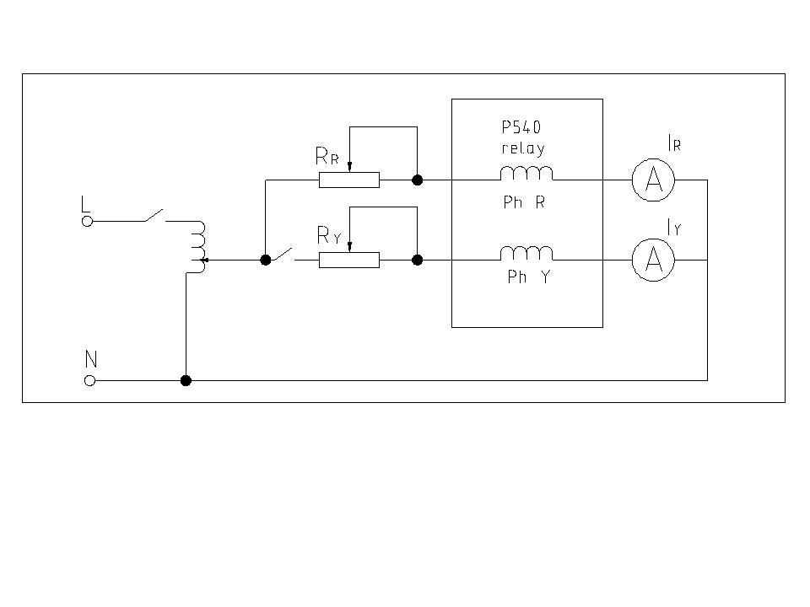

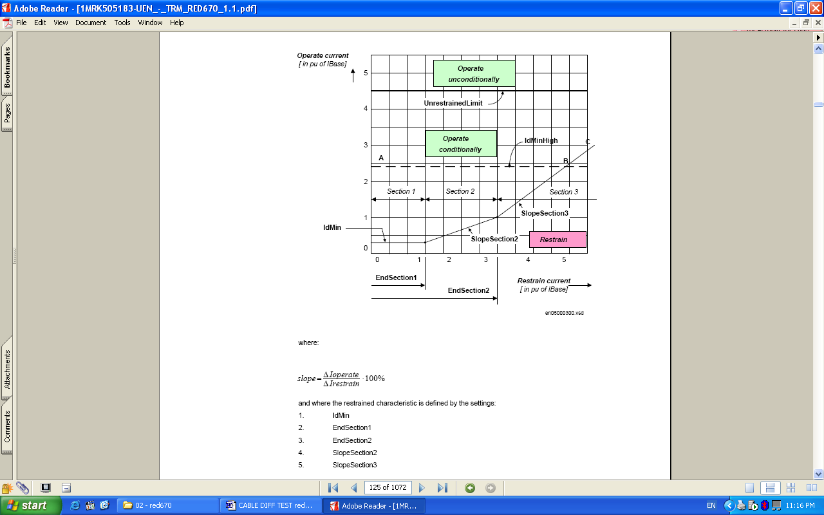

**SLOPE SECTION 2**

Id =

|  |  |  |  |  |  |  |  |  |
| --- | --- | --- | --- | --- | --- | --- | --- | --- |
| **Injected Bias Current (A) in Phase** | | | **Injected Diff Current (A) in Phase** | | | **Expected Pickup (A)** | **Pick Up Current (A)** | **Error %** |
| **R** | **Y** | **B** | **R** | **Y** | **B** |
| 2 |  |  |  | X |  |  |  |  |
|  | 1.75 |  |  |  | X |  |  |  |
|  |  | 1.5 | X |  |  |  |  |  |

**Limits:** ± 2 %Ir According to the Catalogue for Commissioning and Maintenance – Page132

**SLOPE Section3**

Id =

|  |  |  |  |  |  |  |  |  |
| --- | --- | --- | --- | --- | --- | --- | --- | --- |
| **Injected Bias Current (A) in Phase** | | | **Injected Diff Current (A) in Phase** | | | **Expected Pickup (A)** | **Pick Up Current (A)** | **Error %** |
| **R** | **Y** | **B** | **R** | **Y** | **B** |
| 3.5 |  |  |  | X |  |  |  |  |
|  | 4 |  |  |  | X |  |  |  |
|  |  | 5 | X |  |  |  |  |  |

**Limits:** ± 2 %Ir According to the Catalogue for Commissioning and Maintenance –Page132

**3.6.29 HARMONICS RESTRAINT CHECKS:**

|  |  |  |  |  |  |  |
| --- | --- | --- | --- | --- | --- | --- |
| **Harmonics** | **Phase** | **Fundamental Current I1 (A)** | **Harmonics current I2 (A)** | **Setting** | **Measured (%)** | **Remarks** |
| **2nd** | R | 1.0 |  | I2/I1 = 10% |  |  |
| Y | 1.0 |  |  |  |
| B | 1.0 |  |  |  |
| **5th** | R | 1.0 |  | I5/I1 = 25% |  |  |
| Y | 1.0 |  |  |  |
| B | 1.0 |  |  |  |

* + 1. Disturbance recorder checked [ __________ ].
    2. Binary outputs and inputs checked [ __________ ].

1. TestEquipments Used

|  |  |  |  |  |  |
| --- | --- | --- | --- | --- | --- |
| Sl. No | Description | Model | Make | Equipment SL .No | Calibration Due Date |
| 1 | 3ph Secondary Injection kit |  |  |  |  |
| 2 | Multimeter |  |  |  |  |